Server Models
# Source: Chatgpt (GPT-5-Mini) at [1/16/2026]
Server Models describe the architectural design and organization of servers in a system, especially in distributed and client-server systems, and how they handle requests, provide services, and manage resources.
Different server models are used depending on the number of tiers, responsibilities, and performance requirements.

Definition
# Source: Chatgpt (GPT-5-Mini) at [1/16/2026]
A Server Model:
- Defines how servers interact with clients and other servers
- Determines the flow of requests and responses
- Helps design systems for scalability, reliability, and performance

Common Server Models
# Source: Chatgpt (GPT-5-Mini) at [1/16/2026]
1. Client-Server Model
- One or more clients request services from a central server
- Server handles requests, processes them, and sends responses
- Simple, widely used model
Diagram:
Client A -->|
Client B -->|--> Server --> Database
Client C -->|
- Example: Web servers, Email servers

Two-Tier Model
# Source: Chatgpt (GPT-5-Mini) at [1/16/2026]
- Divides system into client tier and server tier
- Client handles the user interface
- Server handles data storage and processing
Diagram:
Client (UI + App) --> Server (Database)
- Example: Small business applications, simple database apps

Three-Tier Model
# Source: Chatgpt (GPT-5-Mini) at [1/16/2026]
- Adds an intermediate layer (application server) between client and database
- Layers: Presentation Layer (Client), Application Layer (Server), Data Layer (Database)
Diagram:
Client (UI) --> App Server (Logic) --> Database Server (Data)
- Example: Enterprise web applications, e-commerce systems

Multi-Tier (N-Tier) Model
# Source: Chatgpt (GPT-5-Mini) at [1/16/2026]
- Extends three-tier to multiple layers
- Layers could include web server, app server, business logic server, database server, cache server
- Improves scalability, maintainability, and fault tolerance
Diagram:
Client --> Web Server --> App Server --> Business Logic Server --> Database
- Example: Large-scale enterprise applications, cloud services

Peer-to-Peer (P2P) Model
# Source: Chatgpt (GPT-5-Mini) at [1/16/2026]
- No dedicated server
- Every node (peer) acts as both client and server
- Resources and requests are shared among peers
Diagram:
Peer A <--> Peer B <--> Peer C
- Example: BitTorrent, Blockchain networks

Key Characteristics of Server Models
# Source: Chatgpt (GPT-5-Mini) at [1/16/2026]
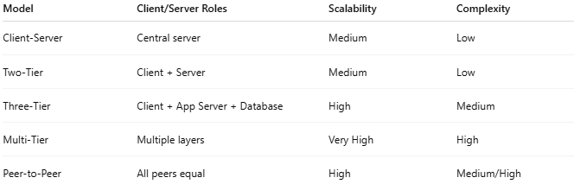
Model | Client/Server Roles | Scalability | Complexity
Client-Server | Central server | Medium | Low
Two-Tier | Client + Server | Medium | Low
Three-Tier | Client + App Server + Database | High | Medium
Multi-Tier | Multiple layers | Very High | High
Peer-to-Peer | All peers equal | High | Medium/High

Simple Analogy
# Source: Chatgpt (GPT-5-Mini) at [1/16/2026]
- Client-Server: One teacher (server) helps all students (clients)
- Two-Tier: Teacher handles both teaching and grading
- Three-Tier: Teacher teaches, assistant grades, library stores books
- Multi-Tier: Teacher, multiple assistants, library, IT staff—all separate roles
- P2P: Students teach and help each other without a central teacher

